

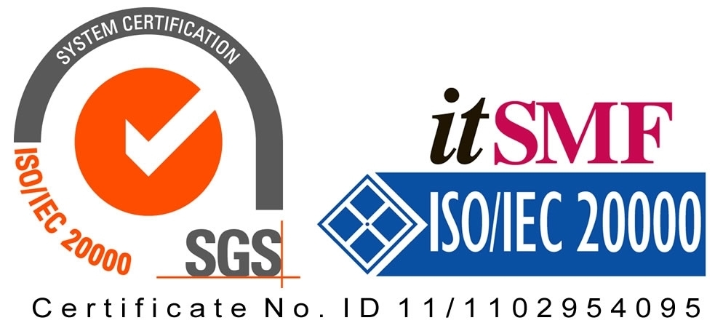

*Operating Lease Support System Development*

**For**



***Functional Specification***

***A.3 Collection Module***

Revision 2.0

**Prepared by:**

**PT. Berlian Sistem Informasi**

KTB Annex Bld. 4th Floor, Jl. Jend. A. Yani. Pulomas,

Tel. +62 21 4786 7575 (Hunting) Fax. +62 21 4714964 [www.bsi.co.id](http://www.bsi.co.id)

Document Control

|  |  |
| --- | --- |
| **Author** | Deny Prasetia |
| **File Name** |  |
| **Path** | N/A |
| **Create Date** |  |
| **Last Edited** | 23/06/2015 08:25:00 |
| **Number of Pages** |  |

Revision History

|  |  |  |  |
| --- | --- | --- | --- |
| **Date** | **Revision** | **Description** | **Author** |
| 25-Nov-2014 | 0.1 | Initial creation | Deny Prasetia |
| 10-Dec-2014 | 1.0 | Baseline | Deny Prasetia |
| 23-Jun-2015 | 2.0 | Update Screen design and Data structure. This update related to Changes Request number IT/CFR/05-06-15/68 | Setiyono |

Distribution List

|  |  |  |
| --- | --- | --- |
| **Name** | **Organization** | **Title** |
| Mr. Abdul Somad | Dipo Star Finance, PT | DSF NBD Head |
| Mr. Ahmad Fikri | Dipo Star Finance, PT | DSF ITD Head |
| Mr. Mukhlis Ibrahim | Dipo Star Finance, PT | DSF ITD |
| Mr. Feri Irawan | Berlian Sistem Informasi, PT | BSI Multifinance Division Head |
| Mr. Asra Haryadi | Berlian Sistem Informasi, PT | BSI Operation Unit Manager |
| Mr. Devilosa Indra Kamal | Berlian Sistem Informasi, PT | BSI Service Manager |

Document Approval

By signing this document I acknowledge I have read the document and give the Project Management Team approval to proceed.

|  |  |  |  |
| --- | --- | --- | --- |
| **Role** | **Name** | **Signature** | **Date** |
| DSF NBD Head | Mr. Abdul Somad |  |  |
| DSF ITD Head | Mr. Ahmad Fikri |  |  |
| DSF ITD | Mr. Mukhlis Ibrahim |  |  |
| BSI Operation Unit Manager | Mr. Asra Haryadi |  |  |
| BSI Service Manager | Mr. Devilosa Indra Kamal |  |  |

Table of Contents

Document Control 2

Revision History 2

Distribution List 2

Document Approval 2

1 Introduction 4

1.1 Purpose 4

1.2 Scope 4

1.3 Acronyms and abbreviations 4

1.4 References 4

2 Detail Specification 5

2.1 Billing and Payment History Inquiry 5

**2.1.1** **Use case** 5

**2.1.2** **Operations and scenarios** 5

**2.1.3** **Status management and roles** 7

**2.1.4** **Sitemap design** 7

**2.1.5** **Screen design** 8

**2.1.5.1** **Billing and payment history inquiry** 8

**2.1.5.2** **Update billing and payment history inquiry** 9

**2.1.6** **Screen features** 10

**2.1.7** **Data structure** 10

3 Appendix 13

3.1 Use Case Terminology 13

1. Introduction
   1. Purpose

Functional specification is to explain some of the following:

1. Describe who uses your application or system,
2. Describe the order in which steps or events or on the scenario are performed,
3. Show user interface design, and
4. What kind of data that will be maintained by functions.
   1. Scope

Marketing module described about how to maintain data transaction on the marketing process which is utilized by functions in the system. On this module there’s no integration with another system (such as ACA and MFAPPL). This modules deal in the “to-be design” for developing the new system.

To keep the accuracy of entire design of the system we are using modeling approach for design and analysis. ***To define a model of functions we will determine use cases. In the use case, it can summarize who uses your application or system, and what they can do with it.***

Within a use case we can determine which use cases are supported by application. We can create use case diagram, activity diagram, use case scenario, data structure, and interface design.

A data structure can be specified what kind of information that will be required for the system. Data structure is represented database design of the system. A user interface design can imagine the user about the system as visual. User interface is designed based on prototypes which have been already created. And, based on these things, we will develop the system.

The following is functionality of collection module:

* Billing Payment History Inquiry

1. Add new billing and payment history records

To input a new billing and payment history records by fill out the form. This feature allows a user to save a data into database, after input on the billing and payment history record form.

1. Update details billing and payment history records

To update a detail billing and payment history records by fill out the details form. This feature allows a user to changes any data, and then saves into database.

1. Filter and sort agreement information

On this feature the record can be filtered and sorted based on columns on top of the list.

1. Validate billing and payment history records

After the records was confirm, the record can be to validate.

1. Set to draft billing and payment history records

If the data still need to be update by user who initiate to create the agreement, the records can be set to draft.

* 1. Acronyms and abbreviations
* ACA : Auto Credit Approval System
* MFAPPL : Multi Finance Application
  1. References

This functional scope refers “to be design” in the section A.1.Marketing Module.

1. Detail Specification
   1. Billing and Payment History Inquiry
      1. **Use case**

The figure below is summarizing who uses features of function, and what they can do with it.

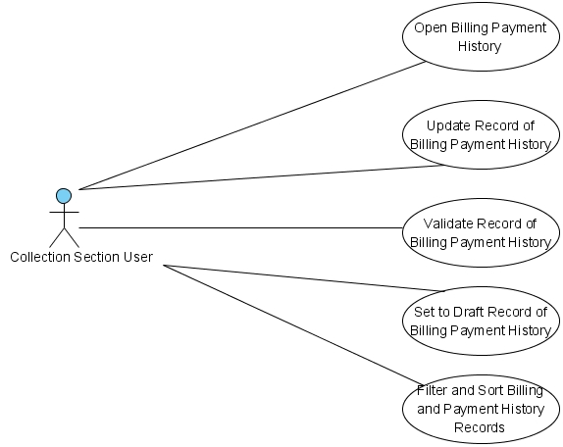

Figure 1 – Use case diagram of Billing and Payment History Inquiry

* + 1. **Operations and scenarios**

The figure below is describing operations or steps performed in a function interact with people (flow of work between actors and the system).

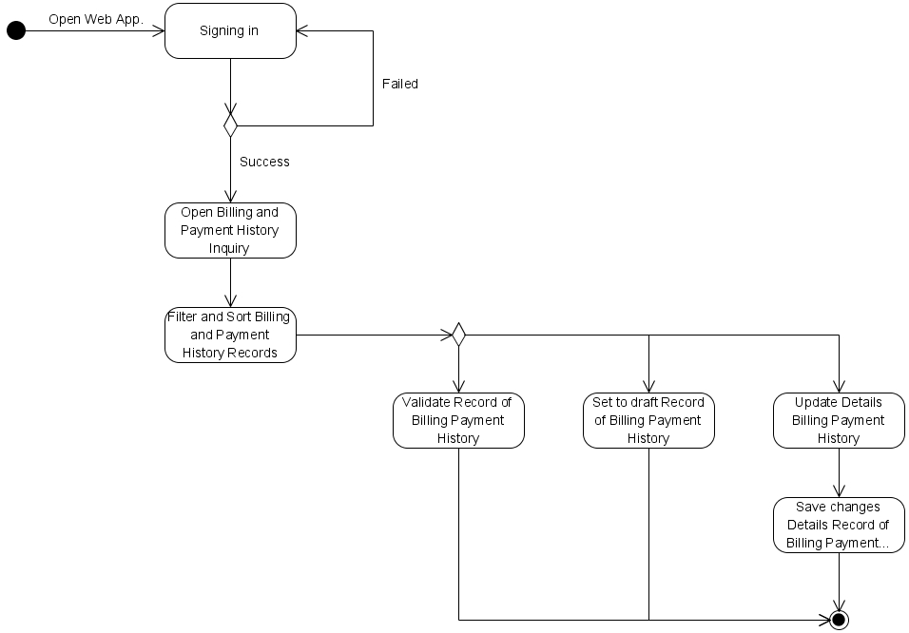

Figure 2 – Activity diagram of Billing and payment history Inquiry

|  |  |  |  |
| --- | --- | --- | --- |
| **No.** | **Steps/ Operations** | **Actor/ People** | **Scenario** |
| 1 | Signing in | Collection Section User | * Actor fills out sign in form by inputting user name and password. * Actor clicks [sign in] button. System will check the account of user; if user account is already registered user will enter into the system. If doesn’t user can return the step. |
| 2. | Open billing and payment history inquiry module | Collection Section User | * After login, actor can open billing and payment history inquiry module on the menu of system. After that, the screen of billing and payment history inquiry will open. |
| 3. | Filter and sort billing and payment history records | Collection Section User | * Actor can filter and sort the record based on columns where displayed on the list. * To filter the records, actor can enter keywords into the filter fields. If matched data founds, the filtered result will be displayed on list. If doesn’t the list will be empty. * To sort the records, actor can click header of column on the list table. After that the records will be sorted by ascending or descending, alternately. * Upon select [record number filter] drop down list, actor can select a records number to display on the list. At least only one item can be selected. |
| 4. | Update billing and payment history record | Collection Section User | * If billing and payment history screen opens, actor can determined the agreement number and police number that want to be display in the billing and payment history. * Upon clicking […] button on the agreement number fields, the agreement look-up screen will be displayed. Agreement number can be selected (only one record can be select). After it’s done, agreement information field will be filled automatically. * After determining agreement number, user can click [Details] button to edit the details of billing and payment history record. Once it done, ‘Details’ screen will be displayed. * If ‘Details’ screen opens, actor can edit a record by inputting a data on each of the fields. * The mandatory fields cannot be blank. |
| 5. | Validate billing and payment history record | Collection Section User | * Once data is saved and data has been confirmed, actor can validate the record by clicking [Validate] button. * After that system will set a record as **validate (or not draft)**. * If done, actor can click back button to return to the list of billing and payment history. |
| 6. | Set to draft of calculation | Collection Section User | * To do this process, actor should open calculation detail screen by clicking [Details] button on the list. Once it open, actor can set to draft by clicking [set to draft] button. If the records still need to revise and status still not valid yet, actor can change the calculation status from **validated** to **draft**. * After that, system will proceed automatically to change the status, and actor can click [Back] button to return to the list. |

* + 1. **Status management and roles**

The figure below is describing a role matrix (including relation with Status) of actor that already identified in a function.

|  |  |  |  |  |  |
| --- | --- | --- | --- | --- | --- |
| **Role of Actor** | **Filter and sort** | **Save as draft** | **Save changes**  **(draft)** | **validate** | **Validate** |
| Maintenance user | Yes | Yes | Yes | Yes | Yes |

The figure below is describing transition of Status that performed when people interact in a function. In this features, drafting process triggered on the agreement module. If service schedule already generated on the agreement module, so the status of service records will be draft too, and vice versa.

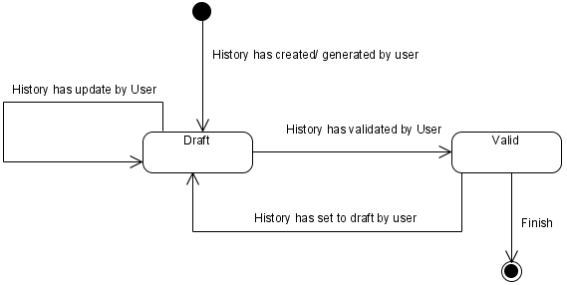

Figure 3 – Status diagram of Calculation of Sales

* + 1. **Sitemap design**

Describe a web page that lists the pages on a web site to users. Usually sitemap organized in hierarchical style.

Figure 4 – Sitemap design of Billing Payment History Inquiry

* + 1. **Screen design**
       1. **Billing and payment history inquiry**

This screen is designed to billing and payment history inquiry. On this screen actor can open service records. And also, actor can open another screen to add and/or update billing and payment history record.

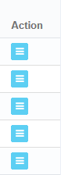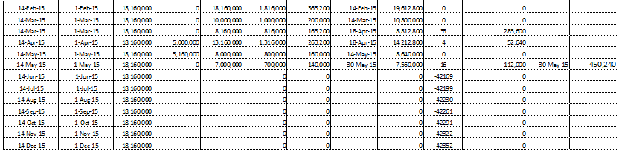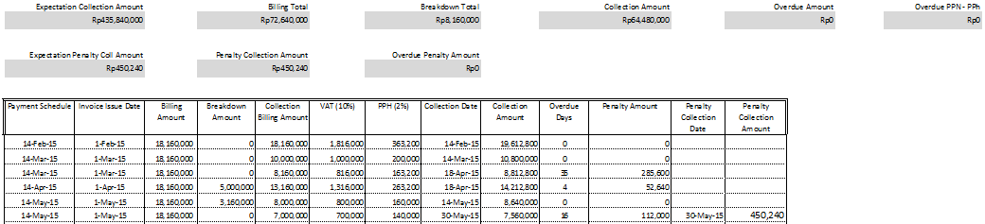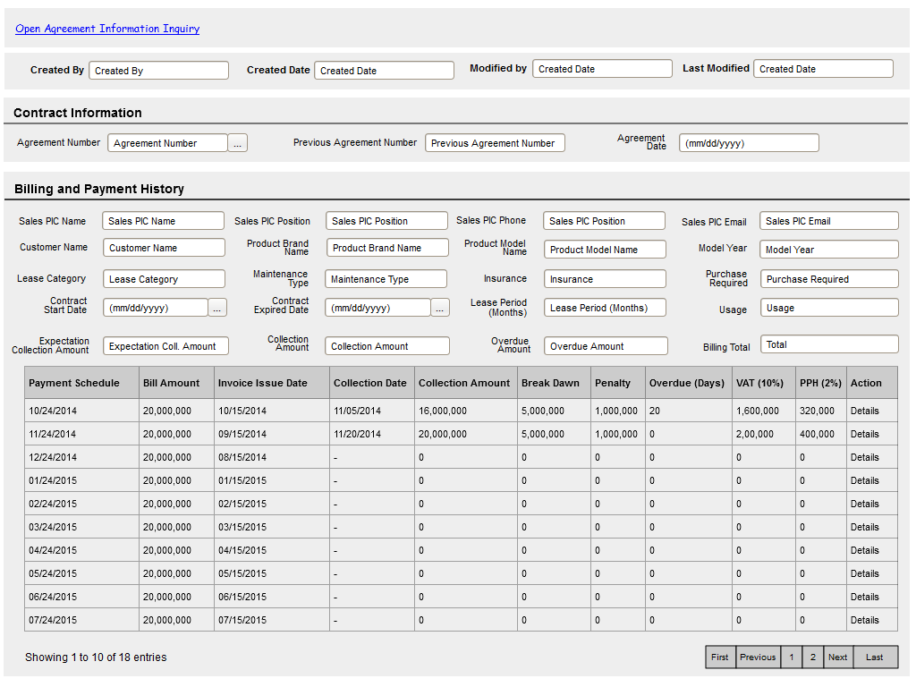

Add new fields

To open details billing and payment history

Data paging information

To open paging of records

To view audit trail

General information of agreement

General information of billing payment history/ payment condition

Image 1 – Billing and Payment History Inquiry Screen

* + - 1. **Update billing and payment history inquiry**

This screen is designed to update the billing and payment history records. After changing some data on the screen, actor can store a data into the system by clicking the action button.

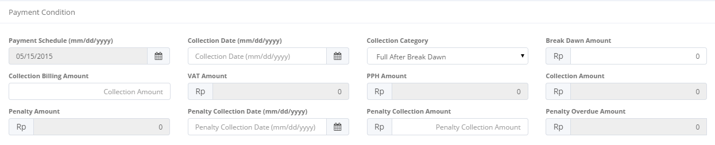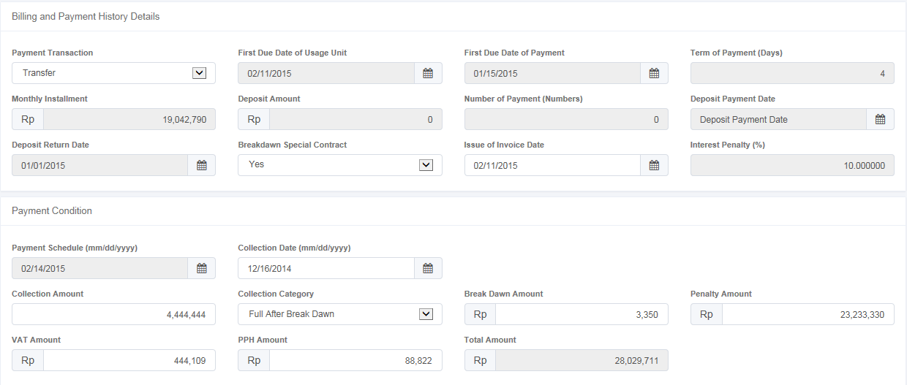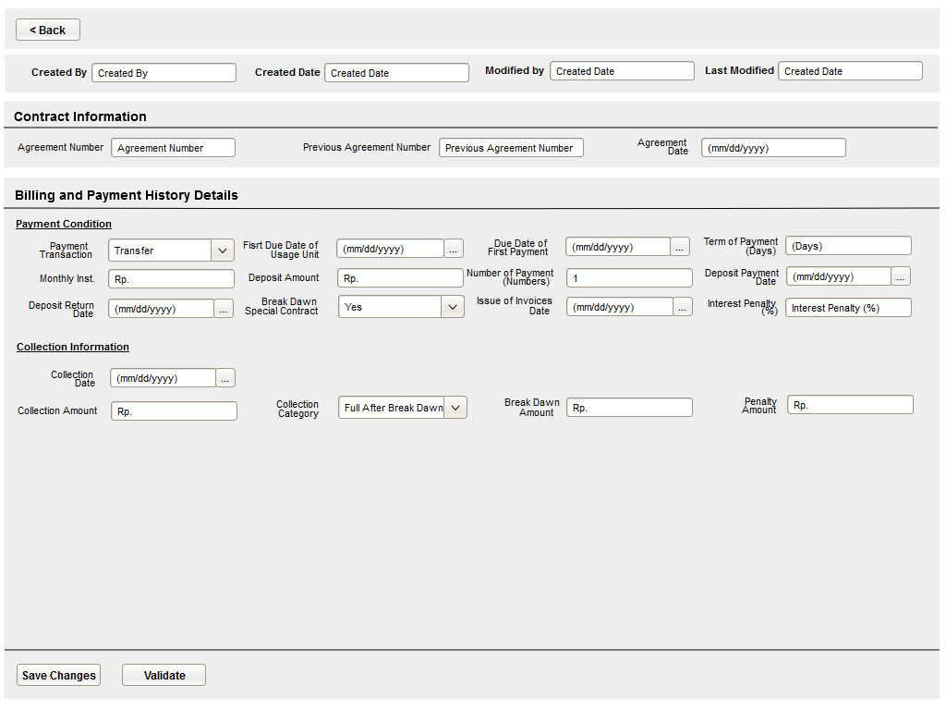

General information of billing payment history/ payment condition

To save and validate a billing and payment records.

To view audit trail

General information of agreement

Image 2 – Screen of Update Details Billing Payment History Inquiry

* + 1. **Screen features**

|  |  |
| --- | --- |
| **Features** | **Description** |
| [Filter and sort] | To perform data filtering and data sorting of calculation records. |
| [Save as draft] or [Set to draft] | To save a record as a draft. |
| [Validate] | To validate a record as a final. |
| [Save changes] | To update changes when editing calculation record. |

* + 1. **Data structure**

|  |  |  |  |  |  |
| --- | --- | --- | --- | --- | --- |
| **Field** | **Data Type** | **Data Length** | **Format** | **Mandatory** | **DB Mapping** |
| **Contract Information** | | | | |  |
| Agreement Number | Varchar | 50 | N/A | *Yes* | OPLAgreement.AgreementNumber |
| Previous Agreement Number | Varchar | 100 | N/A | *No* | OPLAgreement.AgreementNumberReff |
| Agreement Date | Date | N/A | mm/dd/yyyy | *Yes* | OPLAgreement.AgreementDate |
| **Billing and payment history Record** | | | | | |
| Marketing Officer PIC Name | Varchar | 200 | N/A | *Yes* | OPLAgreement.PICFullName |
| Marketing Officer PIC Position | Varchar | 50 | N/A | *Yes* | OPLAgreement.PICPositionName |
| Marketing Officer PIC Phone | Varchar | 50 | N/A | *Yes* | OPLAgreement.PICTelephone |
| Marketing Officer PIC Email | Varchar | 50 | N/A | *No* | OPLAgreement.PICEmailAddress |
| Customer Name | Varchar | 200 | N/A | *Yes* | Customer.CustomerName |
| Product Brand Name | Varchar | 100 | N/A | *Yes* | Product.BrandName |
| Product Model Name | Varchar | 100 | N/A | *No* | Product.ModelName |
| Model Year | Date | N/A | Yyyy | *No* | Product.ModelYear |
| Lease Category | Varchar | 100 | N/A | *Yes* | OPLAgreement.LeaseCategory |
| Maintenance Type | Varchar | 100 | N/A | *Yes* | OPLAgreementDetails.MaintenanceType |
| Insurance | Bit | N/A | N/A | *Yes* | OPLAgreement.IsInsurance |
| Purchase Required | Bit | N/A | N/A | *Yes* | OPLAgreement.PurchaseAfterLease |
| Contract Start Date | Date | N/A | mm/dd/yyyy | *Yes* | OPLAgreement. StartPeriodDate |
| Contract Expired Date | Date | N/A | mm/dd/yyyy | *Yes* | OPLAgreement.EndPeriodDate |
| Lease Period | Int | N/A | N/A | *No* | OPLCalculation.LeasePeriodPlan |
| Usage | Varchar | 100 | N/A | *No* | OPLCalculation.Usage |
| Expectation Collection Amount | Decimal | 18,0 | ###,###,###.## | *Yes* | OPLBillpayHistory.ExpectationCollectionAmount |
| Billing Total | Decimal | 18,0 | ###,###,###.## | *Yes* | OPLBillpayHistory.BillingTotal |
| Breakdown Total | Decimal | 18,0 | ###,###,###.## | *Yes* | *calculation result at runtime |
| Collection Amount | Decimal | 18,0 | ###,###,###.## | *Yes* | OPLBillpayHistory.CollectionAmount |
| Overdue Amount | Decimal | 18,0 | ###,###,###.## | *Yes* | *calculation result at runtime |
| Overdue PPN - PPh | Decimal | 18,0 | ###,###,###.## | *Yes* | *calculation result at runtime |
| Expectation Penalty Collection Amount | Decimal | 18,0 | ###,###,###.## | *Yes* | *calculation result at runtime |
| PenaltyCollectionAmount | Decimal | 18,0 | ###,###,###.## | *Yes* | OPLBillpayHistory.PenaltyCollectionAmount |
| Overdue Penalty Amount | Decimal | 18,0 | ###,###,###.## | *Yes* | *calculation result at runtime |
| **Billing and payment history details** | | | | | |
| Payment Transaction | Varchar | 100 | N/A | *Yes* | OPLBillPayHistoryDetails.PaymentTransactionType |
| First Due Date of Usage Unit | Date | N/A | mm-dd-yyyy | *No* | OPLAgreement. FDueDateUsage |
| First Due Date of Payment | Date | N/A | mm-dd-yyyy | *No* | OPLAgreement. FDDatePayment |
| Term of Payment | Int | N/A | N/A | *No* | OPLAgreement. TermOfPayment |
| Monthly Installment | Decimal | 18,0 | ###,###,###.## | *Yes* | OPLAgreement. TotalMonthlyInstallment |
| Deposit Amount | Decimal | 18,0 | ###,###,###.## | *No* | OPLAgreement. DepositAmount |
| Number of Payment | Decimal | 18,0 | ###,###,###.## | *No* | OPLAgreement. NumberOfPayments |
| Deposit Payment Date | Date | N/A | mm/dd/yyyy | *No* | OPLAgreement. DepositPaymentDate |
| Deposit Return Date | Date | N/A | mm/dd/yyyy | *No* | OPLAgreement. DepositReturnDate |
| Breakdown Special Contract | Bit | N/A | N/A | *No* | OPLAgreementDetails.BreakDawnContract |
| Issue of Invoice Date | Date | N/A | mm/dd/yyyy | *No* | OPLBillPayHistoryDetails.InvoiceIssueDate |
| Interest Penalty | Decimal | 18,6 | ###,###,###.## | *No* | OPLAgreement. InterestOfPenalty |
| **Payment Condition** | | | | | |
| Payment Schedule | Date | N/A | mm/dd/yyyy | *Yes* | OPLBillPayHistoryDetails.PaymentSchedule |
| Collection Category | Varchar | 100 | N/A | *Yes* | *defined |
| Break Dawn Amount | Decimal | 18,0 | ###,###,###.## | *No* | OPLBillPayHistoryDetails.BreakDawnAmount |
| Penalty Amount | Decimal | 18,0 | ###,###,###.## | *No* | OPLBillPayHistoryDetails.PenaltyAmount |
| VAT Amount | Decimal | 18,0 | ###,###,###.## | *No* | OPLBillPayHistoryDetails.VATAmount |
| PPH Amount | Decimal | 18,0 | ###,###,###.## | *No* | OPLBillPayHistoryDetails.PPHAmount |
| Total Amount | Decimal | 18,0 | ###,###,###.## | *No* | OPLBillPayHistoryDetails.BillAmount |
| Collection Date | Date | N/A | mm/dd/yyyy | *No* | OPLBillPayHistoryDetails.CollectionDate |
| Collection Amount | Numeric | N/A | N/A | *No* | OPLBillPayHistoryDetails.CollectionAmount |
| **Audit Rail** | | | | | |
| Create By | Text | 100 | N/A | *Yes* | CreateBy |
| Create Date | Date time | N/A | mm-dd-yyyy:hh-mm-ss | *No* | CreateDate |
| Last Modified By | Text | 100 | N/A | *Yes* | LastModifiedBy |
| Last Modified | Date | N/A | mm-dd-yyyy | *No* | LastModified |
| **Status Management** | | | | | |
| Is Deleted | Yes/No | N/A | N/A | *Yes* | IsDeleted |
| Is Draft | Yes/No | N/A | N/A | *Yes* | IsDraft |
| Is Submitted | Yes/No | N/A | N/A | *Yes* | IsSubmitted |
| Is Valid | Yes/No | N/A | N/A | *Yes* | IsValid |

1. Appendix
   1. Use Case Terminology

|  |
| --- |
| ***What is the use case?***   1. ***A use case is*** *a written description of how users will perform tasks on your website.  It outlines, from a user’s point of view, a system’s behavior as it responds to a request. Each use case is represented as a sequence of simple steps, beginning with a user's goal and ending when that goal is fulfilled. (*[*http://www.usability.gov/how-to-and-tools/methods/use-cases.html*](http://www.usability.gov/how-to-and-tools/methods/use-cases.html)*)* 2. ***A use case is*** *a list of steps, typically defining interactions between a role and a system. (*[*http://en.wikipedia.org/wiki/Use_case*](http://en.wikipedia.org/wiki/Use_case)*)* 3. ***A use case is*** *a formal way of representing how a business interacts with its environment. it summarized into a single picture.* ([*http://romisatriawahono.net/lecture/sad/romi-sad-05-implementation-march2014.pptx*](http://romisatriawahono.net/lecture/sad/romi-sad-05-implementation-march2014.pptx)*)*   ***What are Benefits of use cases?***   1. ***Use cases*** *add value because they help explain how the system should behave and in the process, they also help brainstorm what could go wrong.  They provide a list of goals and this list can be used to establish the cost and complexity of the system. Project teams can then negotiate which functions become*[*requirements*](http://www.usability.gov/how-to-and-tools/methods/requirements.html)*and are built.*     *(*[*http://www.usability.gov/how-to-and-tools/methods/use-cases.html*](http://www.usability.gov/how-to-and-tools/methods/use-cases.html)*)*   1. *With the help of use case diagram, you can discuss and communicate:*  * *The scenarios in which your system or application interacts with people, organizations, or external systems.* * *The goals that it helps those actors achieve.* * *The scope of your system.*   *(*[*http://msdn.microsoft.com/en-us/library/dd409432.aspx*](http://msdn.microsoft.com/en-us/library/dd409432.aspx)*)* |